Full stack developer 2023 App documentation

1. UML Use Case Diagram

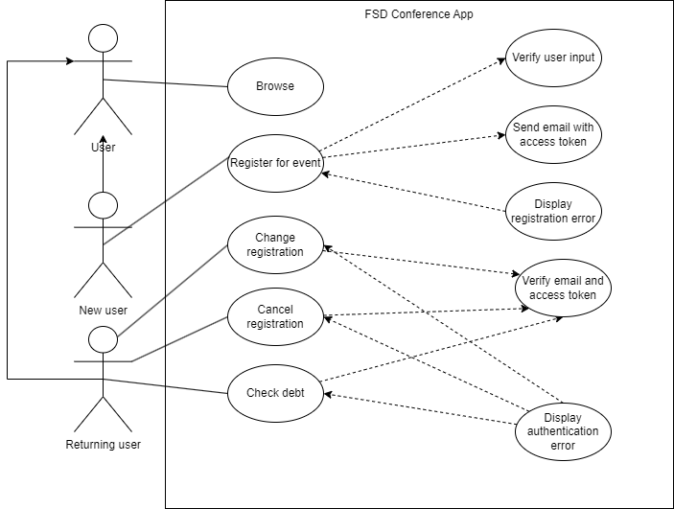

1. Logical Data Model diagram

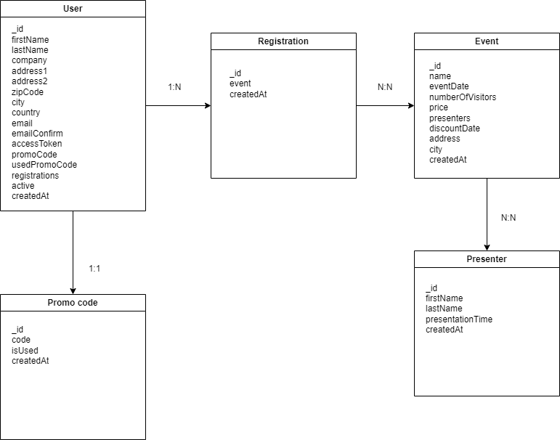

1. IDEF1X Physical Model Diagram

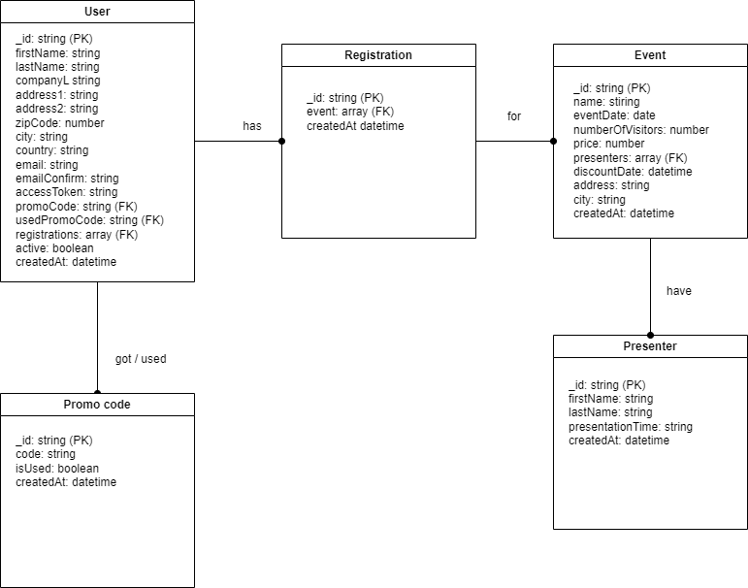

1. Sequence Diagram for feature 2

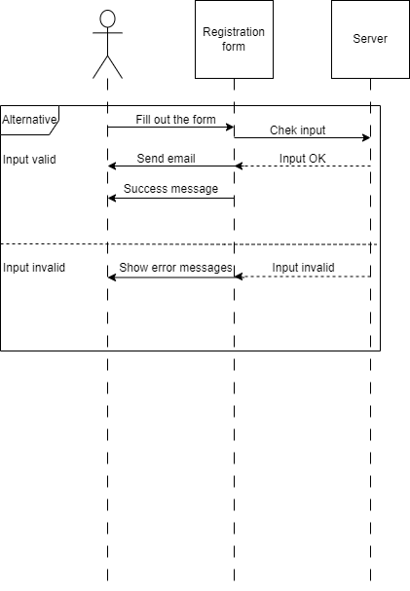

1. Class Diagram for whole app

